Virtual launch – Rise up together:
Women’s role in transforming Africa’s food systems
Africa Green Revolution Forum (AGRF) 2020 pre event
Monday, 7th September 2020; 17:00 – 18:00 CAT

Social media toolkit

Background

Moving forward on agriculture in Africa and achieving sustainable, productive food systems hinges on establishing gender equality.

The newly established CGIAR GENDER Platform will hold a launch event during this year’s Africa Green Revolution Forum (AGRF 2020), which will seek feedback on select research priorities and aim to establish diverse partnerships so that we, together, can advance a portfolio of promising, practical, useful solutions for gender equality in agriculture.
The event is scheduled for Monday 7 September at 1700 CAT.

More information

Hasthtags

#AGRF2020 #FeedTheCities #OneCGIAR #GenderinAg #Genderequality

Partners to tag where feasible
- @CGIAR
- @ACIARAustralia
- @CanadaDev
- @karinagould
- @wilde_vicki
- @gatesfoundation
- @IDRC_CRDI
- @jemimah_njuki
- @ILRI
- @UN_Women
- @cipotato
- @CIFOR
- @RockefellerFdn
- @BiovIntCIAT_eng

Download images for social media:
https://cip.chorus.thirdlight.com/link/DesignsGenderPlatform

Tweets

#Women play a key role in transforming Africa’s #foodsystems.  Norms and policies should therefore include women’s preferences, realities, and ambitions. @CanadaDev @IDRC_CRDI  Join launch of @CGIARgender  👉🏼 http://bit.ly/Event-GenderPlatform  #AGRF2020 #FeedTheCities #onecgiar  🔸 @CanadaDev  🔸 @IDRC_CRDI | 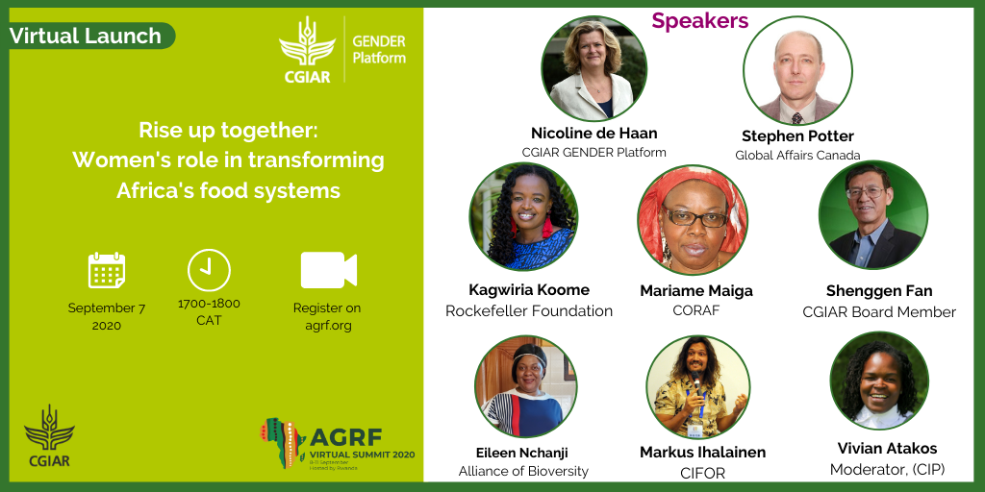
.@CGIARgender advances a portfolio of promising, practical, tried, tested, & useful interventions to achieve gender equality in agric—in pursuit of more equitable, sustainable #FoodSystems.  Join launch:  👉🏼 http://bit.ly/Event-GenderPlatform  #AGRF2020 #onecgiar  🔸 @gatesfoundation | 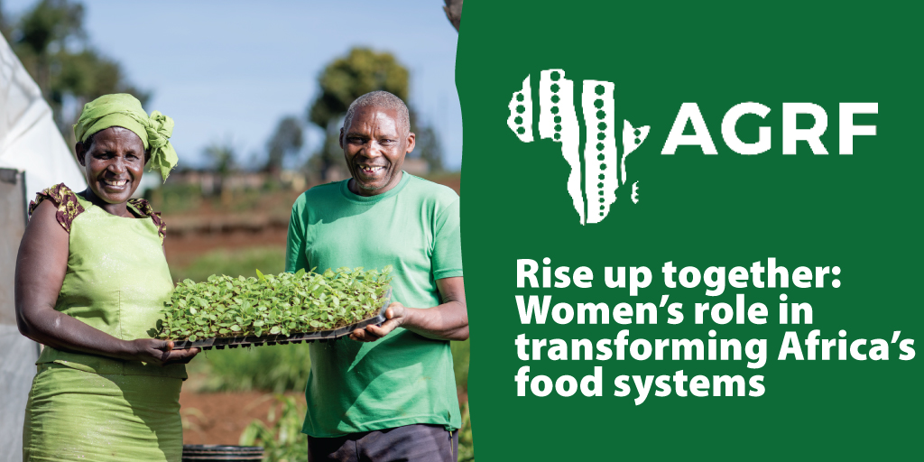
The @CGIARgender platform is designed to put #gender #equality at the forefront of global agricultural research for development.  Join virtual launch 7 Sep  👉🏼 http://bit.ly/Event-GenderPlatform  #FeedTheCities #GenderinAg  🔸 @CGIAR  🔸 @ACIARAustralia  🔸 @jemimah_njuki | 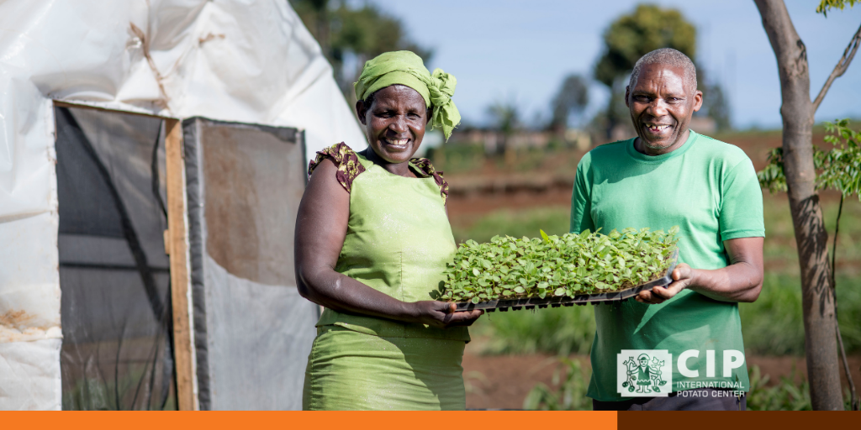
🗓️ 7 Sep #Launching @CGIARgender.  Only when #women are able to participate on equal footing with men, in the urgently needed transformation of #foodsystems will we be able to sustainably defeat hunger  👉🏼 http://bit.ly/Event-GenderPlatform  #AGRF2020 #onecgiar  🔸 @karinagould  🔸 @wilde_vicki | 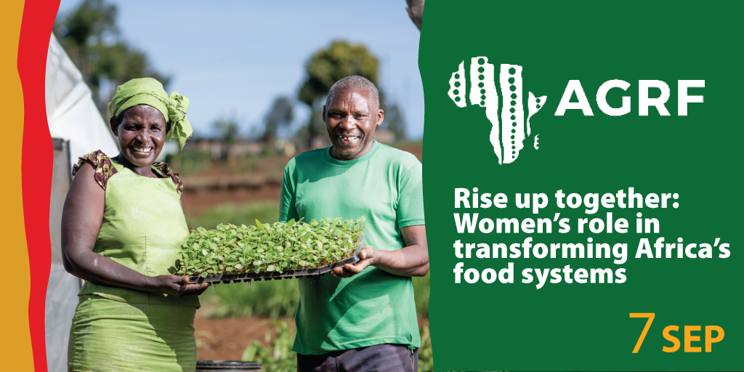
🗓️ 7 Sep #Launching @CGIARgender.

Only when #women are able to participate on equal footing with men, in the urgently needed transformation of #foodsystems will we be able to sustainably defeat hunger

👉🏼 http://bit.ly/Event-GenderPlatform

#AGRF2020 #onecgiar

🔸 @karinagould
🔸 @wilde_vicki

Facebook post
Moving forward on agriculture in #Africa and achieving sustainable, productive food systems hinges on establishing gender equality.

Join @CGIARgender during #AGRF2020:

👉🏼 http://bit.ly/Event-GenderPlatform

📅 7 September
🕙 17:00-18:00 CAT

#FeedTheCities #GenderinAg

Additional tweets for CIP personnel

By ensuring our interventions are gender responsive, we empower #women to improve the #nutrition of their families and contribute to the #foodsystems tranformation this and future generations need.  👉🏾 https://bit.ly/CIPNutrition  🔸 @CGIARgender  🔸 @cipotato  #AGRF2020 #feedthecities #OneCgiar | 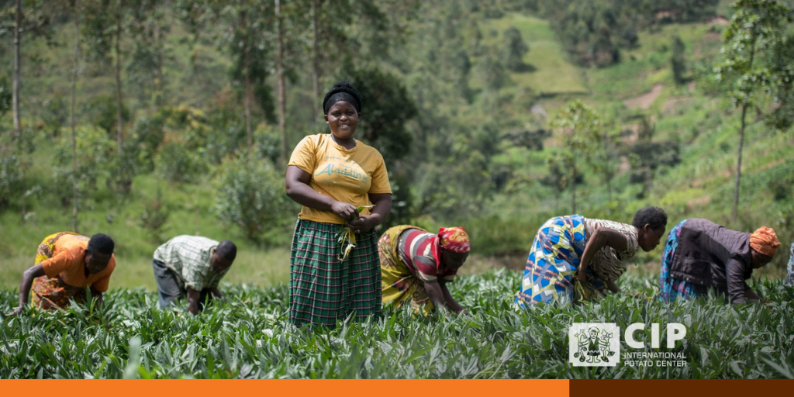
By involving local #women and men in the selection of #climate-smart crop varieties, we can ensure widespread adoption and help communities adapt to #climatechange.  👉🏾 https://bit.ly/CIPNutrition  🔸 @CGIARgender  🔸 @cipotato | 