CGIAR BIG DATA IN AGRICULTURE VIRTUAL CONVENTION 2020:
DIGITAL DYNAMISM FOR ADAPTIVE FOOD SYSTEMS
SOCIAL MEDIA TOOLKIT
CGIAR scientists are increasingly tapping the power of big data to enhance their development of solutions to the world’s most pressing challenges. The current pandemic and steady advance of climate change add urgency to this work, and highlight the need for more agile and adaptive approaches. This inclusive, virtual event convenes experts from across the globe to present and discuss ways that advances in digital technology can be harnessed to help the world build back better, and transform the food system.
From October 19—23, under the theme of Digital Dynamism for Adaptive Food Systems, the CGIAR Big Data in Agriculture Convention 2020 offers information and insights on current trends in the use of big data and digital technologies in research for development. The event is free of charge, available online to anyone interested. Speakers will present and discuss cutting-edge innovations and gender-responsive digital tools and technologies that can facilitate the detection, analysis, and response to major challenges to food and nutrition security.
Two ways to join the social media campaign:
- Upload suggested statements and supplementary photos to increase awareness of event. Feel free to tweak the statements to highlight your organization’s participation.

- Publish your own social media messages that highlight your organization’s work relevant to this event. Impact stories, trivia cards, call to actions, and invitation to join the conversation are encouraged. Tag partners and other participating organizations and use hashtags that connect to other issues.

Primary event hashtag
- #BDPGLOBAL2020
Secondary hashtags for campaigns
- #OneCGIAR
- #BigDataInAg
- #FoodSecurity
- #ClimateChange
Download images for social media:
https://cip.chorus.thirdlight.com/link/BigData2020

SOCIAL MEDIA MESSAGES
Twitter
CIP is tapping the power of #BigData to accelerate delivery of #tech to improve #FoodSecurity, build #resilience to global shocks, & contribute to #FoodSystems transformation.  👉🏽 http://bit.ly/BigData-Challenges  🔸 @CGIAR_Data  🔸 @BTIscience  #BDPGLOBAL2020 #OneCGIAR | 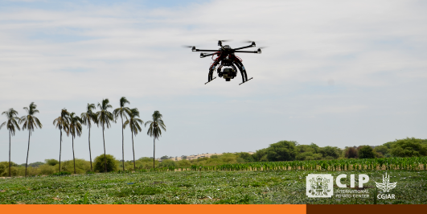
@Cipotato use #BigData to enhance its work to conserve biodiversity, develop new crop varieties, improve natural resource management and help farmers adapt to #ClimateChange.

👉🏽 http://bit.ly/BigData-Challenges

🔸 @CGIAR_Data
🔸 @CGIAR_EiB
🔸 @CGIAR

#BDPGLOBAL2020 #OneCGIAR
@Cipotato scientists developed a phone app 📲 to help farmers control late blight disease – responsible for USD billions in crop loss annually – with less agrochemicals, benefitting farmers and environment.  👉🏽 http://bit.ly/App-Potato  🔸 @CGIAR_Data  #BDPGLOBAL2020 #OneCGIAR | 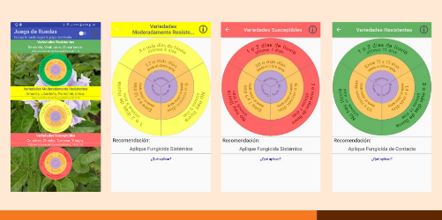
By helping #potato 🥔 farmers cut their agrochemical use, a phone app 📲 developed by @Cipotato scientists can reduce risks to the health of farmers 👩🏽‍🌾 and the #environment.  👉🏽 http://bit.ly/App-Potato  🔸 @CGIAR_Data  #BDPGLOBAL2020 #OneCGIAR #BigDataInAg | 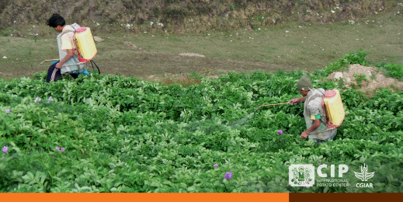
@Cipotato scientists used #BigData to develop open-access software and a dynamic #digital tool that can help farmers 👩🏽‍🌾 produce food with less water 💧.  👉🏽 http://bit.ly/Digital-WaterAgri  🔸 @CGIAR_Data  🔸 @RTB_CGIAR  #BDPGLOBAL2020 #OneCGIAR #SDGs #FoodSecurity #ClimateChange | 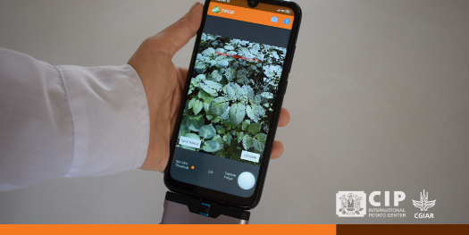
Using thermography and #BigData, @Cipotato scientists studied potato’s response to #water 💧 stress and developed a dynamic #digital tool to help farmers optimize their use of water in irrigation.  👉🏽 http://bit.ly/Digital-WaterAgri  🔸 @CGIAR_Data  🔸 @RTB_CGIAR  #BDPGLOBAL2020 #OneCGIAR #SDGs | 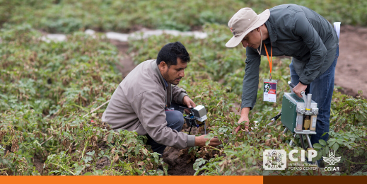

Facebook
Agriculture 🌱 accounts for about 70 percent of global freshwater use and global warming is making water scarce in many areas.  @Cipotato scientists have used thermography to study potato’s 🥔 response to water stress and develop a dynamic digital tool that can help farmers optimize their use of water for irrigation.  Good for farmers. Good for the planet 🌍.  👉🏽 http://bit.ly/Digital-WaterAgri  🔸 @BigDataCGIAR  🔸 @CGIAR | 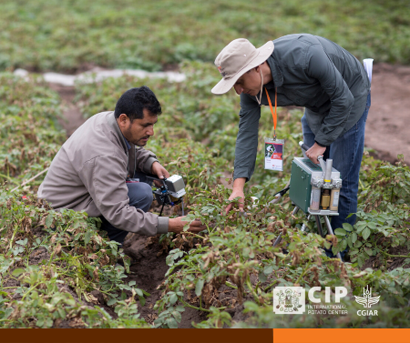
@Cipotato scientists 👨🏽‍🔬 are using drones and other digital tools in field studies to enhance their understanding of plant responses to stress, accelerate the development of climate-resilient crop varieties, and contribute to the transformation of food systems.  👉🏽 http://bit.ly/BigData-Challenges  🔸 @BigDataCGIAR  🔸 @CGIAR  🔸 @CGIAR.EiB | 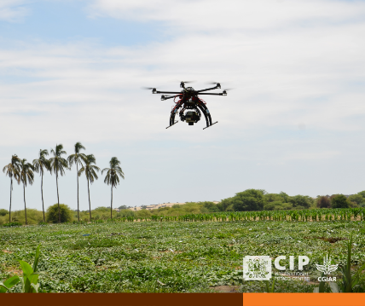
Late blight disease is the biggest threat to potato 🥔 farming, causing USD billions of crop loss each year. To control it, farmers regularly spray fungicides on their crop.  @Cipotato scientists used big data to develop a phone app 📲 that can help farmers control late blight with less agrochemicals.  Good news for farmers and the environment!  👉🏽 http://bit.ly/App-Potato  🔸 @BigDataCGIAR | 